*The* ***Need by Date*** *in direct quotes, sales orders and service segments must be filled in.*

# WHAT?

1. What is the **Need by Date**?

* It is a date that all the parts must be dispatched by to meet the date the customer/service department requires to receive the items taking into account the agreed delivery method(s)
* You must agree the date with the customer as part of the sales process but update it and check in with the customer as needed based on new information.

## WHO?

1. Who should start updating the **Need by date**?

* All staff creating direct quotes, sales orders or segments.

## WHEN?

1. When should I start entering the **Need by Date**?

* Now. Note - soon a configuration change will be made and when that happens the field will not allow you to move on until it's filled in.

## HOW?

1. How do I determine what the **Need by Date** should be?

* Use the [**Freight Estimator Tool**](http://chcaxdw1/Reports/report/Gough%20NAXT%20Reports/Sales/Freight%20Estimator%20Tool) report to find all parts to be backordered (not in NZ).

**Intranet > Everything to support NAXT > Reports & Forms > Reports Register > Search for “Freight Estimator Tool” and click on the link**

* In NAXT look up CAT on-hand and item availability for parts to be backordered.

**Intranet > Everything to support NAXT > Sales Order (Parts) >PRT_1.1(SOP)Identify Parts and Check Availability**

* In NAXT refer to the lead time in days from origin facilities shown on the Freight Estimator.

**Intranet > Everything to support NAXT > Sales Order (Parts) > PRT_5.4(SOP)Recover Freight**

* Look at the big picture. If one part is going to take a month via sea freight, there is no need to hotline the other parts. Talk to the customer to agree a date based on this.
* Do not guess the date. The customer will tell you if the parts are urgent.

## WHY?

1. Why does the customer benefit from us entering the **Need by Date**?

* We can provide a better service to customers by understanding their needs
* We can choose the best service for airfreight based on the date
* We can provide information to CAT

1. Why does CAT want us to enter the **Need by Date**?

* To measure our ability to provide parts to customers **on time and in full** (OTIF).
* We will be able to use this reporting to have fact-based discussions with customers on how well we have performed in this area.

## WHERE?

1. Where do I fill in the **Need by Date** in NAXT?

* In a quote, segment and sales order when creating them, and on an SO header when updating the date.

**PRT_1.2_Create and Manage a Sales Quote**,Step 8

**PRT_2.3_Create and Update a Sales order**, Step 4, Step 7

**SER_1.3_Service call structure** Step 20 (intranet),45, d) (sharepoint)

***Note****: The* ***Need by date*** *can be updated at any time but changes should be discussed with the customer.*

***Note:*** *There are other places in NAXT the* ***Need by date*** *can be updated, but please limit updates to the places shown above*.

## TRACKING?

1. How do I find sales orders past the **Need by date**?

* Assign this cue “**PRT – (your branch) Sales orders past Need by Date**” to your branch and start using it! For instructions on how to assign the cue:

**Intranet > Everything to support NAXT > Quick Reference Guides >** [**QRG_Create and Manage Cues in NAXT**](http://intra/files/qrg---create-and-manage-naxt-cues-pdf-rzt33I.pdf)

1. How do I track parts coming from CAT?

* Use **OTV** or the [**Purchased Parts Tracking**](http://chcaxdw1/Reports/report/Gough%20NAXT%20Reports/Product/PartTrackingReport)report to track parts on POs.

**Intranet > Everything to support NAXT > Reports & Forms > Reports Register > Search for “Purchased Parts Tracking” and click on the link**

1. How do I track parts all undelivered parts for segment or customer number or sales order?

* Go to **NAXT**: **GGNZ > Sales and Marketing > Reports > Transactions > Sales orders > Back order lines (Gough)**

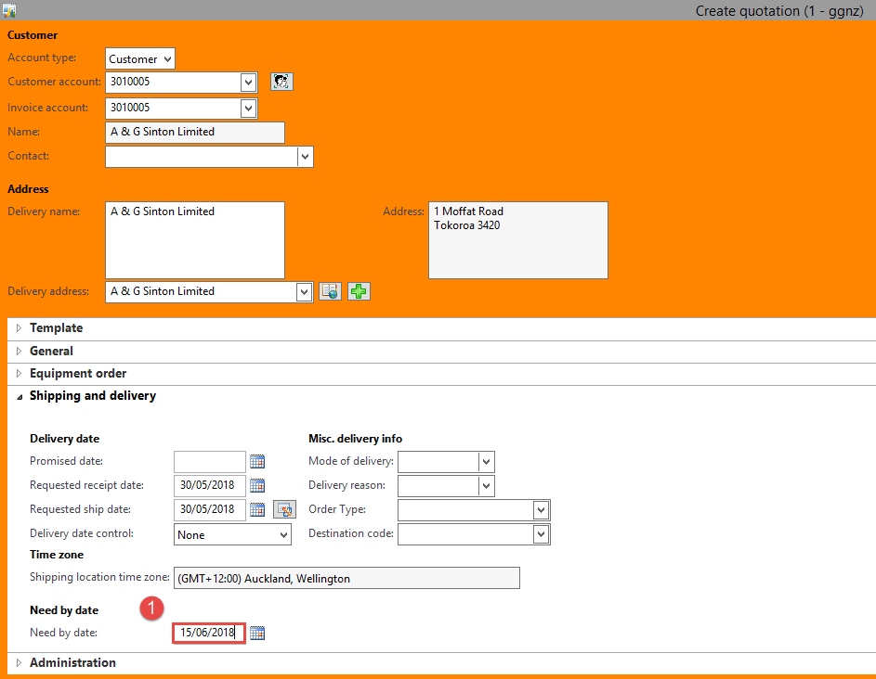

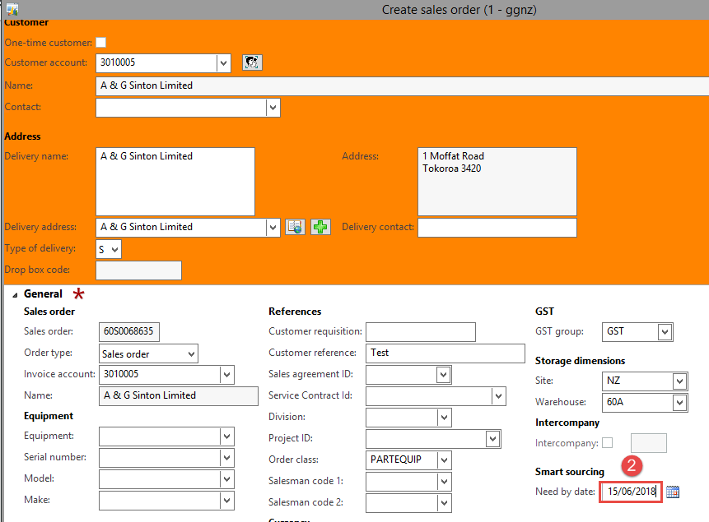**NAXT Quick tips**

**Filling in the Need by date**

1. When creating a quote
2. When creating a sales order
3. In the sales order header

if it needs updating

1. When creating a segment

